**exp 1: how to create react app**

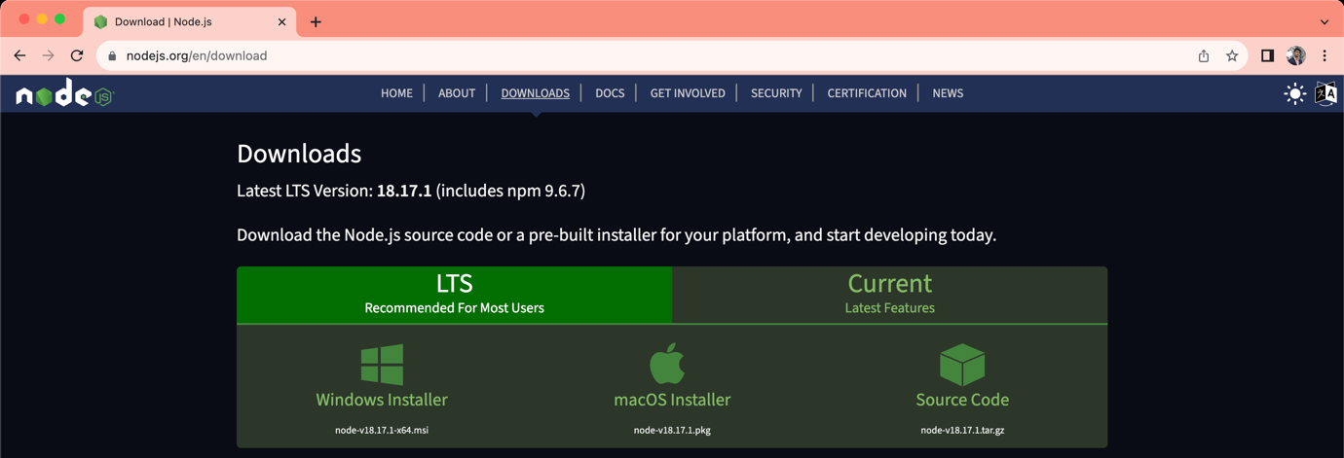

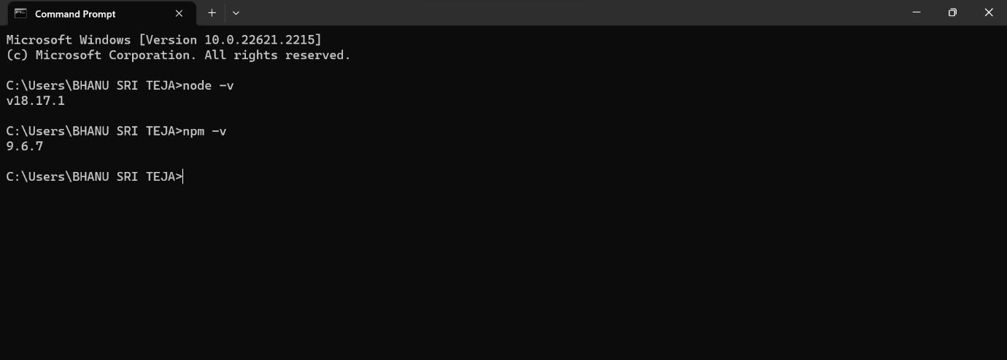

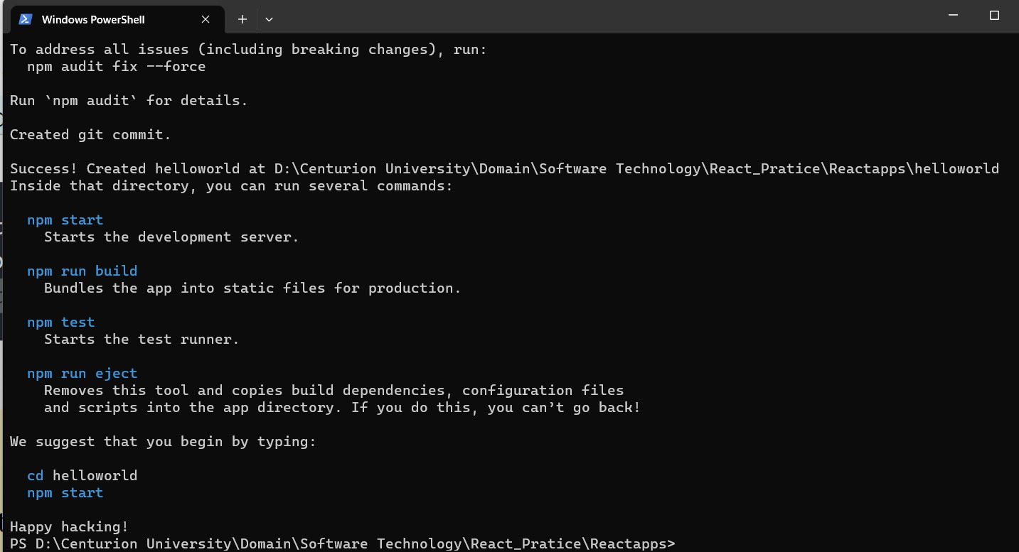

**exp 2: class based component**

**App.js**

import React,{Component} from 'react';

class App extends Component{

  render(){

    return(

      <div>

        <center>

          <h1>REACT</h1>

          <h1>WELCOME TO LEACTURE </h1>

  <h2>TOPIC:- CLASS COMPONENTS </h2>

<h4> When creating a React component, the component's name must start with an upper case letter. <br/> The component has to include the extends React. <br/> Component statement, this statement creates an inheritance to React.Component, <br/>and gives your component access to React.Component's functions.<br/>The component also requires a render() method, this method returns HTML.</h4>

        </center>

      </div>

    )

  }

 }

  export default App;

EXP-2 OUTPUT:-

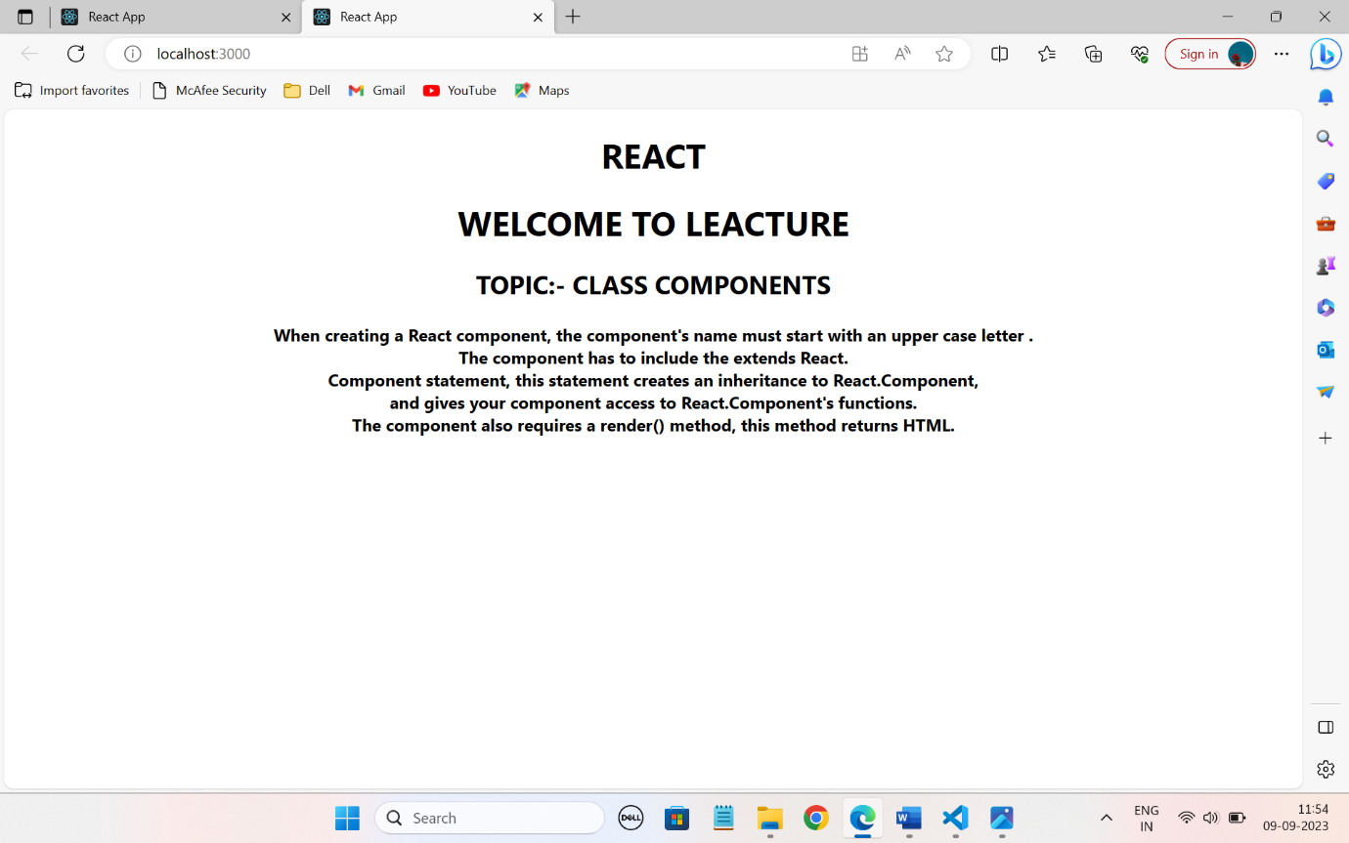

**Exp 3: nested class based component**

**App.js**

import React,{Component} from 'react';

import First from './First';

 class App extends Component{

  render(){

    return(

      <div>

        <center>

          <h1>WELCOME EVERYONE</h1>

        <First />

        </center>

      </div>

    )

  }

 }

  export default App;

**first.js**

import React,{Component} from 'react';

 class First extends Component{

  render(){

    return(

      <div>

        <center>

        <h1>TOPIC:- NESTED CLASS BASED COMPONENT </h1>

        <h4>A nested component is any child component linked to a parent component. <br/> This relationship between the child and parent components is formed through composition rather than inheritance. <br/> This is to say that rather than inheriting one component from another, each component is created by assembling smaller ones</h4>

        </center>

      </div>

    )

  }

 }

 export default First;

EXP 3 OUTPUT:-

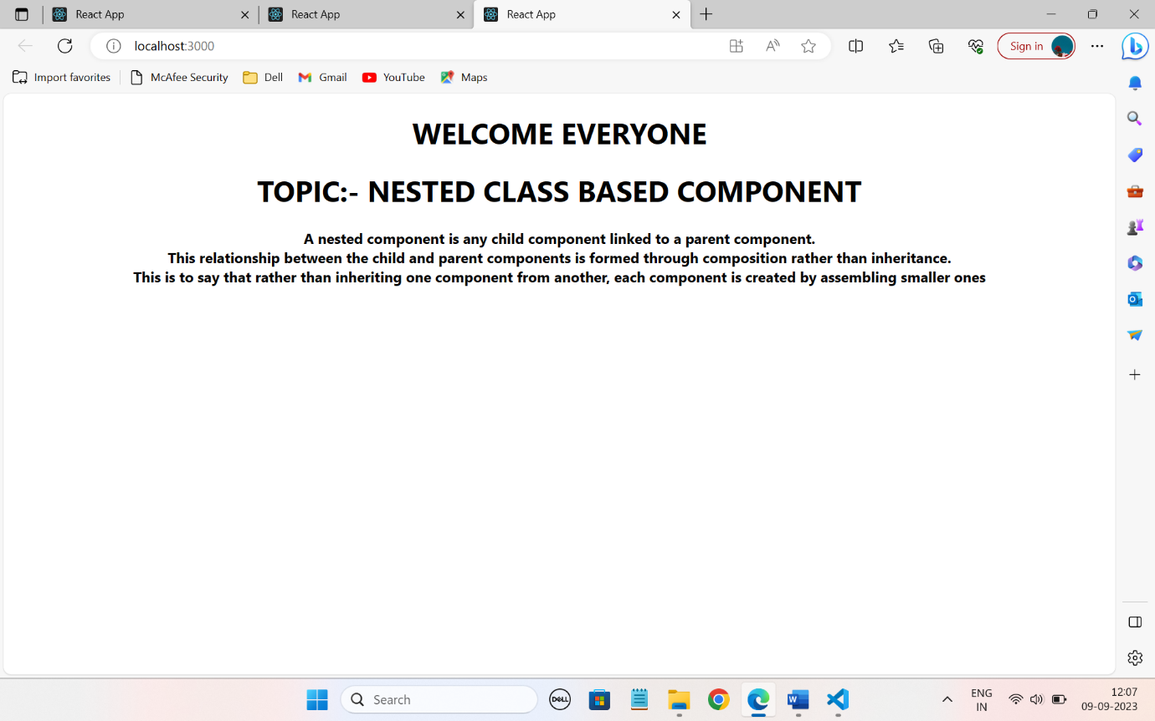

**exp 4: functional based component**

**App.js**

import React from 'react'

 function App() {

  return (

    <div>

      <center>

        <h1> WELCOME EVREYONE!!</h1>

      <h2> TOPIC:-  FUNCTIONAL COMPONENTS</h2>

      <p>Functional components are just javascript functions, which contains some logic to perform certain actions. <br/>These components accept the data as props and return the React element which is nothing HTML content. With introduction to the React 16, <br/>writing functional components is the standard way of creating components in modern react applications.</p>

      </center>

    </div>

  )

}

export default App;

EXP 4 OUTPUT:-

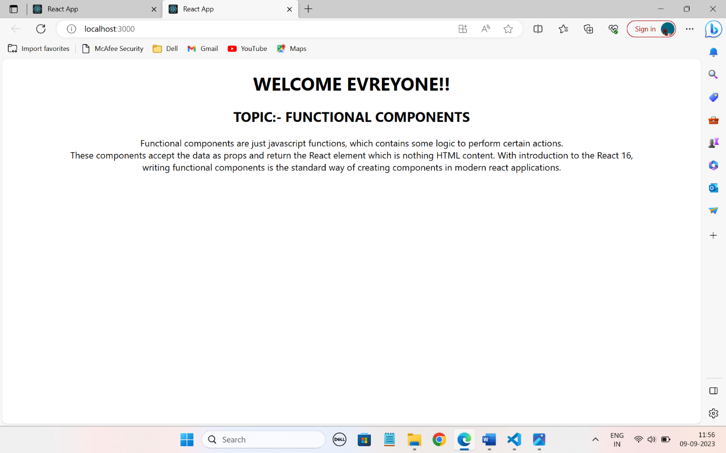

**exp 5: functional based component with arrow function**

**App.js**

const App=()=>{

  return(

    <div>

      <center>

      <h1>Functional Based Component with Arrow Function</h1>

        <p> The arrow function is a new feature of ES6, introduced in ReactJS 16.<br/> It allows the developer to create a function that has lexical “this” binding and no arguments.<br/>Arrow functions are one of the many things that make React code more concise and easier to read.<br/>When used correctly, they can help your code become more declarative and easier to understand. <br/>They are a concise way to write functions that do not have their own this, arguments, or new.Target.<br/> This means that they are not suited for use as methods in objects or classes.</p>

      </center>

    </div>

  )

}

export default App;

EXP 5 OUTPUT:-

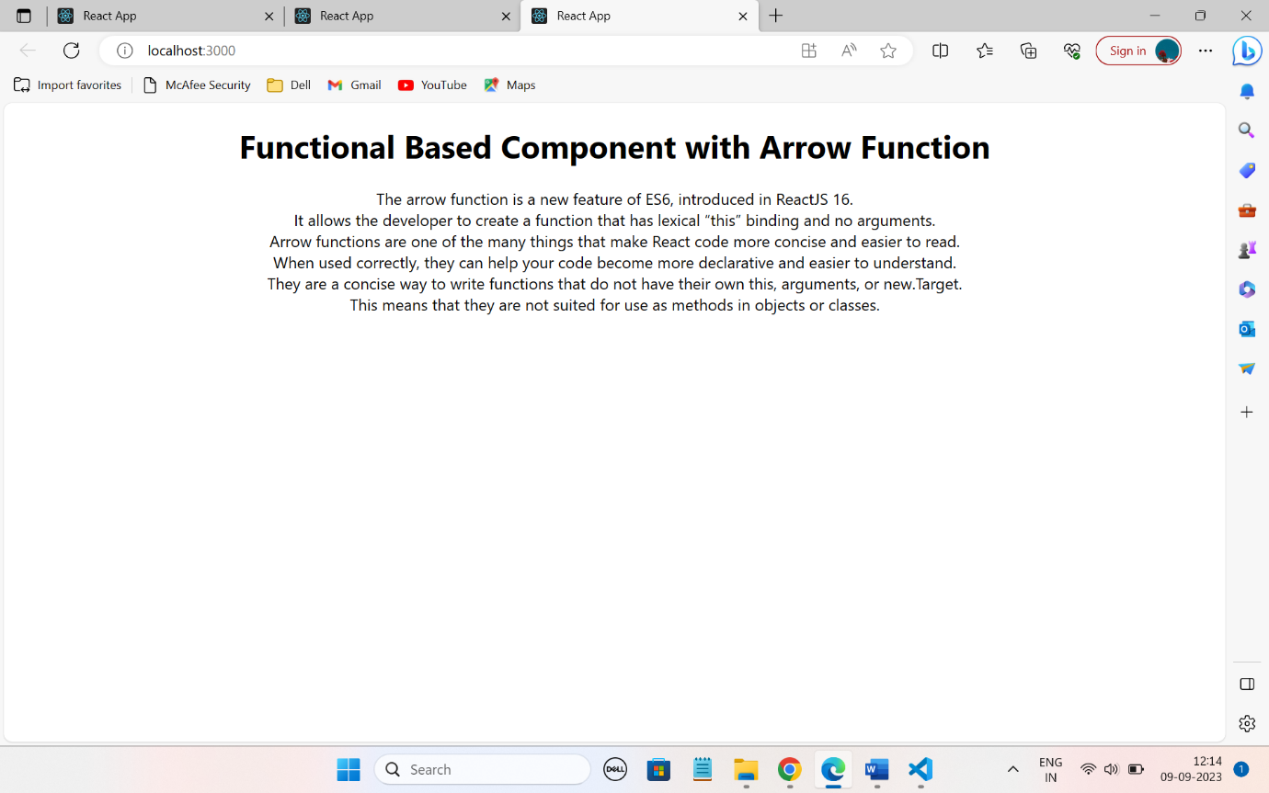

**Exp 6: Nested Functional Based Component**

**App.js**

import React from 'react'

import First from './First';

 function App() {

  return (

    <div>

      <center>

        <h1> WELCOME GUYS!!</h1>

        <First />

      </center>

    </div>

  )

}

export default App;

**First.Js**

import React,{Component} from 'react';

 class First extends Component{

  render(){

    return(

      <div>

        <center>

        <h1>TOPIC:- Nested Functional Based Component </h1>

      <h4>A nested component is any child component linked to a parent component. <br/> This relationship between the child and parent components is formed through composition rather than inheritance. <br/> This is to say that rather than inheriting one component from another, each component is created by assembling smaller ones</h4>

        </center>

      </div>

    )

  }

 }

 export default First;

EXP 6 OUTPUT:-

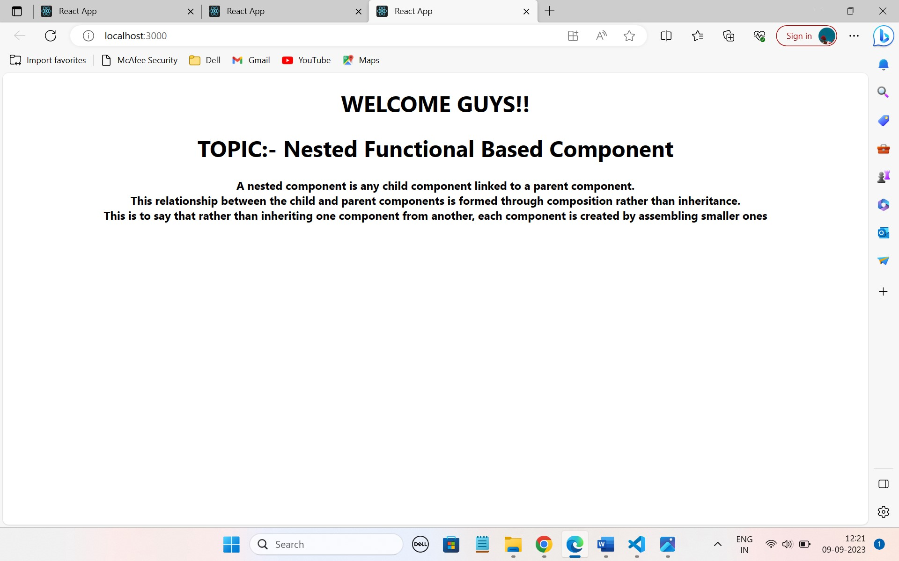

**Exp 7: State in Functional based component**

import React from 'react'

 const App=()=>{

  const state={

    name:'Bhanu Sriteja',

    age:19,

    college:'Centurion University',

    location: 'vizianagaram',

    branch:'CSW',

    subject:'React',

    }

  return(

    <div>

      <center>

        <h1> STATE IN FUNCTION BASED COMPONENT </h1>

        <h2>Name={state.name}</h2>

        <h2>College={state.college}</h2>

        <h2>location={state.location}</h2>

        <h2>Age={state.age}</h2>

        <h2>Branch={state.branch}</h2>

        <h2>subject={state.subject}</h2>

      </center>

    </div>

  )

 }

export default App;

EXP 7 OUTPUT:-

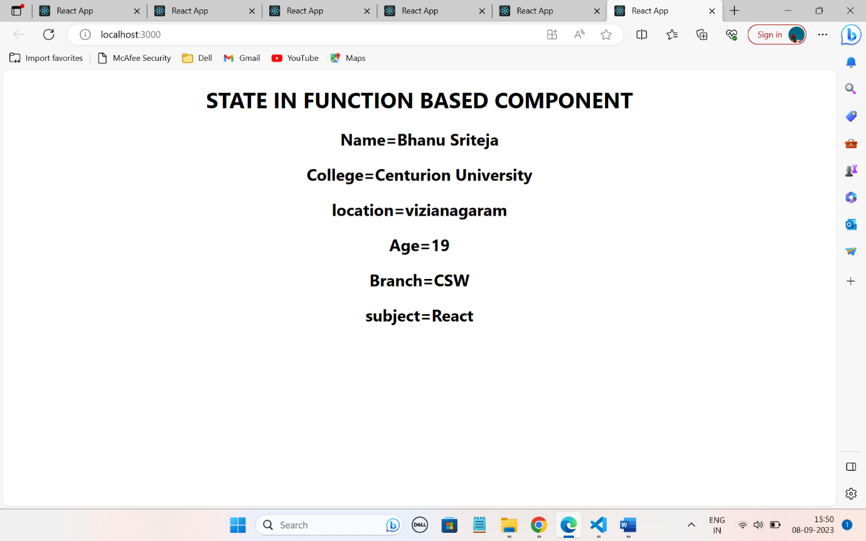

**Exp 8: State in Class based component**

import React, { Component } from 'react'

 class App extends Component {

   state={

    name:"BHANU SRITEJA",

    domain:"CSW",

    regno:2,

  }

  render() {

    return (

      <div>

        <center>

        <h1> STATE IN CLASS BASED COMPONENT </h1>

        <h2>Name:{this.state.name}</h2>

        <h2>Domain:{this.state.domain}</h2>

        <h2>Regno:{this.state.regno}</h2>

        </center>

      </div>

    )

  }

}

export default App;

exp 8 ouput:-

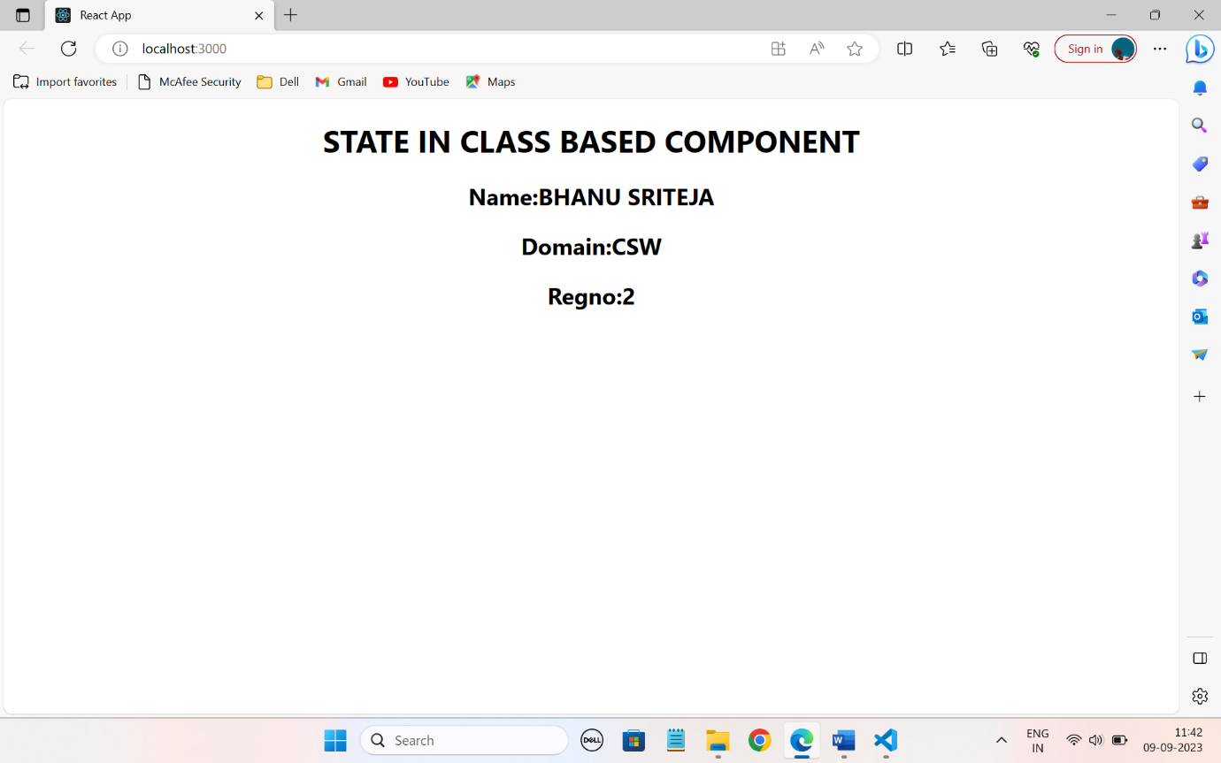

**EXP 9: Props in Class based Component**

**App.js**

import React, { Component } from 'react'

import First from './First';

 class App extends Component {

   state={

    name:"BHANU SRITEJA",

    age:19,

  }

  render() {

    return (

      <div>

        <center>

        <First name={this.state.name}

        age={this.state.age} />

        </center>

      </div>

    )

  }

}

export default App;

**First.js**

import React from 'react';

class First extends React.Component{

    render(){

        return(

            <div>

                <center>

                    <h1>Welcome!!</h1>

                <h2>Name:{this.props.name}</h2>

                <h2>Age:{this.props.age}</h2>

                </center>

            </div>

        )

    }

}

export default First;

**exp 9 output:-**

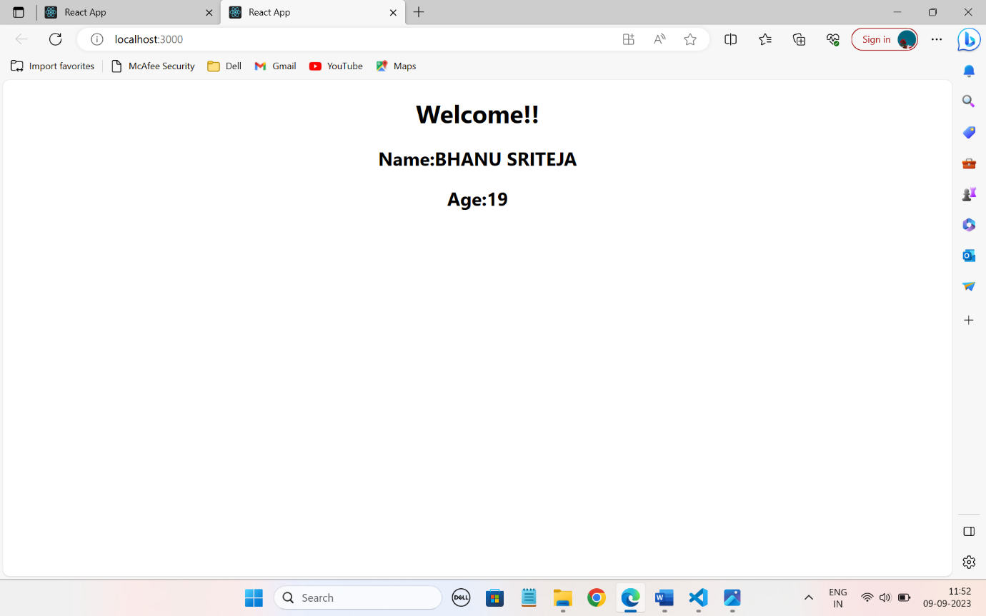

EXP 10 :- How to handle to props concept in function based component

APP.JS

import React from 'react'

import First from './First'

 const App=()=>{

  const state={

    name:'BHANU SRITEJA',

    age:19,

    college:'Centurion University',

    branch:'CSW',

    regno:211801340002,

    }

  return(

    <div>

      <center>

        <First name={state.name}

        college={state.college}

        branch={state.branch}

        regno={state.regno}/>

      </center>

    </div>

  )

 }

export default App;

FIRST.JS

import React from 'react'

 const First=(props)=> {

  return (

    <div>

      <center>

        <h1> <b>DETAILS OF THE STUDENT</b></h1>

        <h2>Name:{props.name}</h2>

        <h2>College:{props.college}</h2>

        <h2>Branch:{props.branch}</h2>

        <h2>regno:{props.regno}</h2>

      </center>

      </div>

  )

}

export default First;

OUTPUT:-

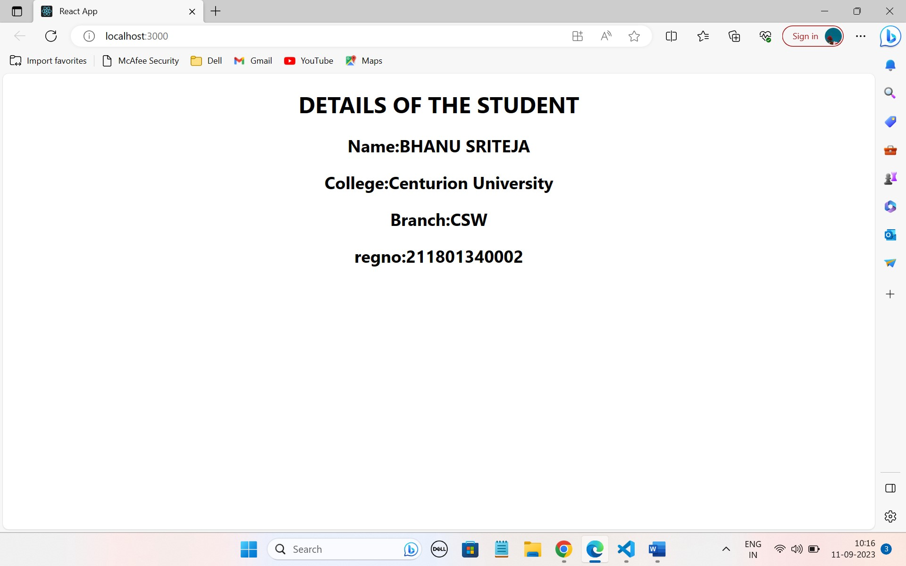

**11. Event handlers-onclick**

import React from 'react'

const App = () => {

  return (

    <div>

      <center><br/>

      <h1>  React Tutorial</h1>

      <h4>React is a JavaScript library for building user interfaces.<br/>

          React is used to build single-page applications.<br/>

          React allows us to create reusable UI components.

        </h4>

        <img src="https://knackforge.com/wp-content/uploads/2022/11/Benefits-of-ReactJS.jpg" height="200" width="300"></img> <br/>

      <br/>

      <h1>

      <button onClick={()=>alert('Thankyou for Subscribing')

    }>Click me</button>

    </h1>

      </center>

    </div>

  )

}

export default App

**OUTPUT:-**

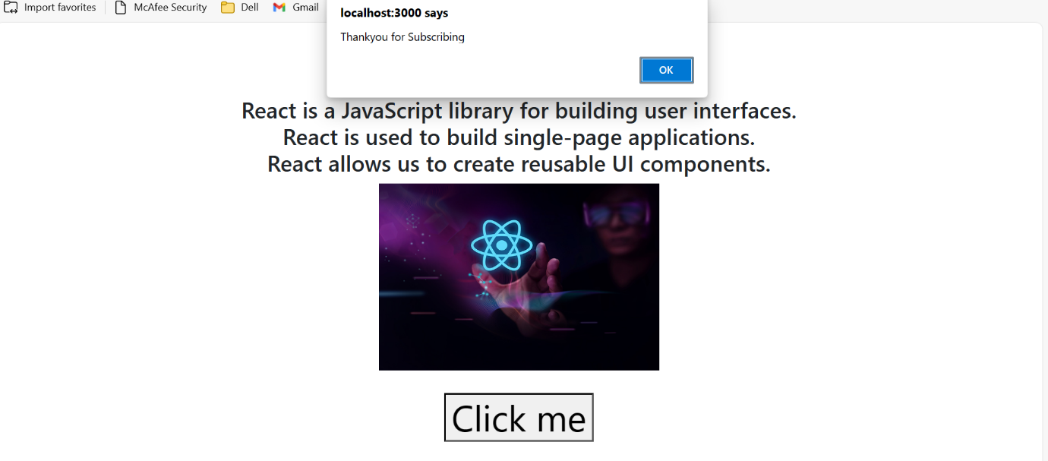

**EXP12:-** **Hooks -useState**

import React ,{useState}from 'react'

const App = () => {

  const[ number,setNumber] = useState(0);

  const handler=()=>{

    setNumber(number+1)

  }

  return(

    <div>

      <center>

        <button onClick = {handler}> Click me </button>

      <h1>{number}</h1>

      </center>

    </div>

  )

}

export default App

OUTPUT:-

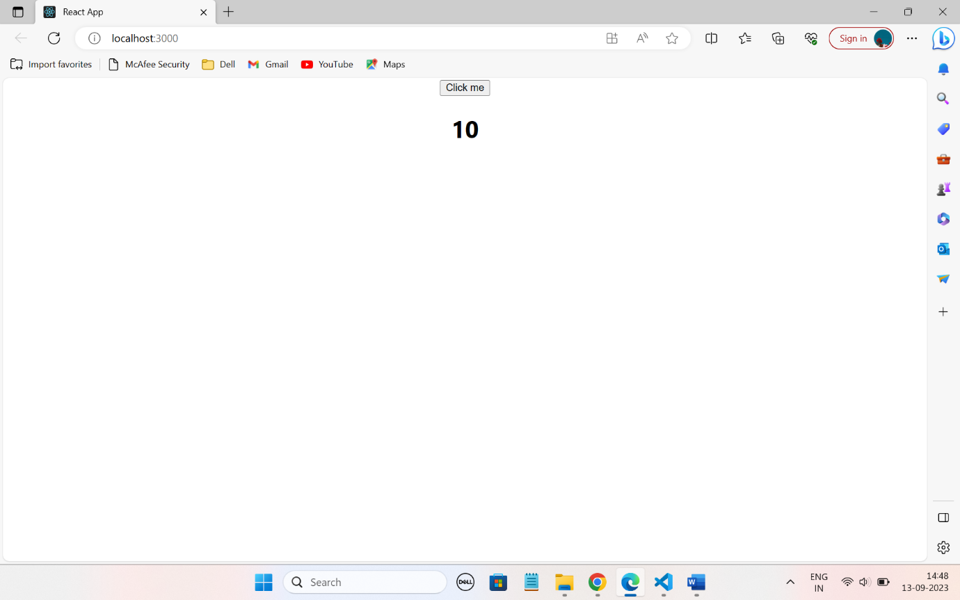

EXP

import React ,{useState} from 'react'

const App = () => {

  const[name,setName]= useState(" Bhanu");

  return(

    <div>

      <center>

      <form>

        <input type="text" name='username' placeholder='Enter your Name'/>

      </form>

      <h1>{name}</h1>

      </center>

    </div>

  )

}

export default App

**EXP 13:-** **Event handler -onchange**

import React ,{useState} from 'react'

const App = () => {

  const[name,setName]= useState("");

  const handler=(e)=>{

    setName(e.target.value)

  }

  return(

    <div>

      <center>

      <form>

        <input type="text" name='username' value={name} onChange={handler} placeholder='Enter your Name'/>

      </form>

      <h1>{name}</h1>

      </center>

    </div>

  )

}

export default App

OUTPUT:- 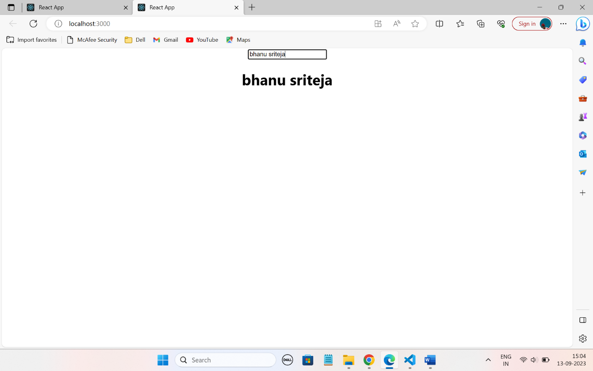

**EXP 14:- Event handler-onsubmit**

import React ,{useState} from 'react'

const App = () => {

  const[data,setData]= useState({

    username:"",

    password:""

});

  const handler=(e)=>{

    setData({...data,[e.target.name]:e.target.value})

  }

  const submitHandler=()=>{

    console.log(data)

  }

  return(

    <div>

      <center>

      <form onSubmit={submitHandler}>

        <input type="text" name='username' onChange={handler} placeholder='Enter your username'/> <br/>

        <input type="password" name='password'  onChange={handler} placeholder='Enter your password'/> <br/>

  <input type="email" name='email' onChange={handler} placeholder='Enter your Email'/> <br/>

      <button name= 'Submit'>Submit</button>

      </form>

      </center>

    </div>

  )

}

export default App

OUTPUT:-

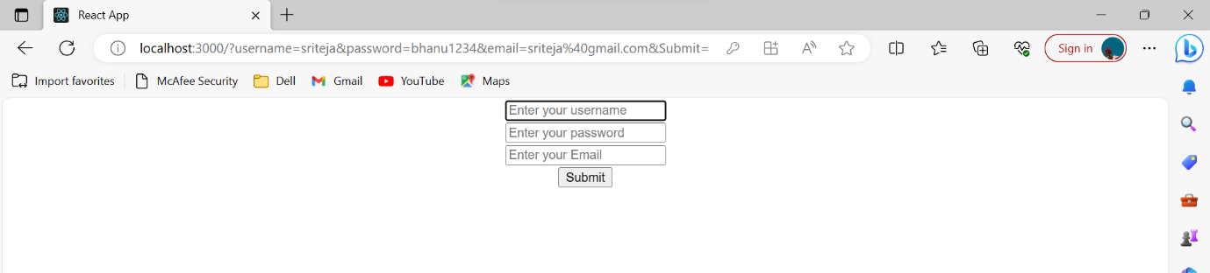

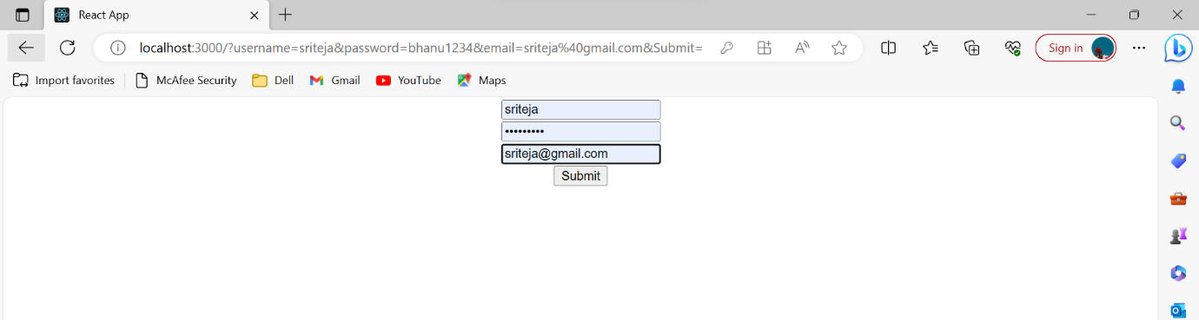

**15. Hooks-useEffect Increment and Decrement**

import React,{useState,useEffect} from 'react'

const App = () => {

  const[number,setNumber]=useState(0);

  useEffect(()=>{console.log(number)},[number])

  return (

    <div>

      <center> <br/>

      <h1>

      <button  style={{fontFamily:"Times new Roman"}} onClick={()=>{setNumber(number+1)}}>Click increment </button>

      <button  style={{fontFamily:"Times new Roman"}} onClick={()=>{setNumber(number-1)}}> Click decrement</button>

      </h1>

      <h2>{number}</h2>

      </center>

      </div>

  )

}

export default App

output:-

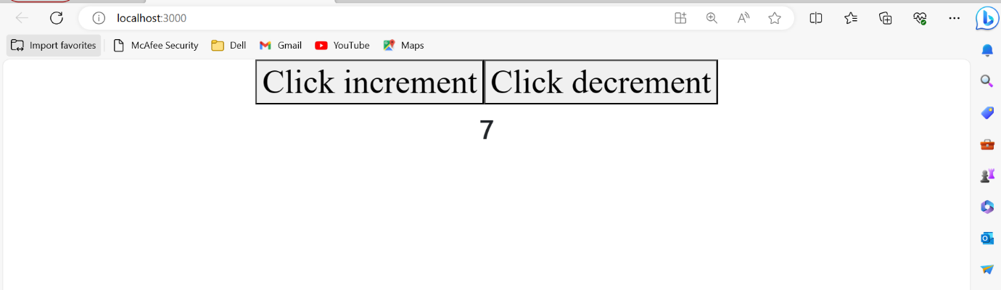

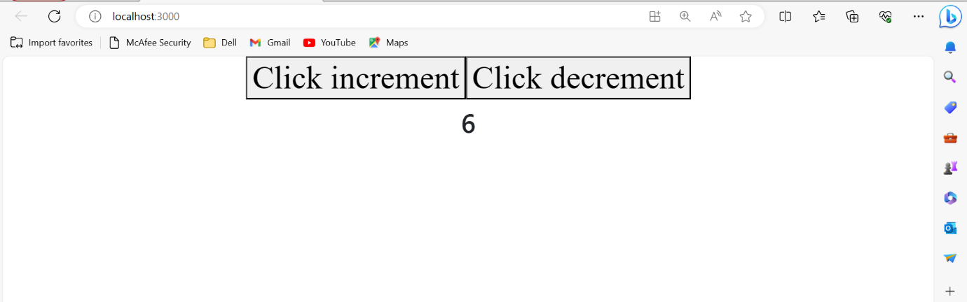

**EXPERIMENT :-** **Form handling -validation**

**App.js**

import React ,{useState,useEffect} from 'react'

const App = () => {

  const[data,setData]= useState({

    username:"",

    password:"",

    confirmpassword:"",

    mail:"",

    phoneno:""

  })

  const changeHandler=(e)=>{

    setData({...data,[e.target.name]:e.target.value})

  }

  const submitHandler=(e)=>{

    e.preventDefault()

    console.log(data)

    if(data.username.length<=6){

      alert("Enter the above char");

    }

    else{

      console.log(data)

  }

}

  return(

    <div class="App">

      <center>

      <form onSubmit={submitHandler}>

        <h2 class="apple">REGISTRATION FORM</h2><br/>

        <input type="text" name='username'   onChange={changeHandler} placeholder='Enter your username'/> <br/> <br/>

        <input type="password" name='password' onChange={changeHandler} placeholder='Enter your password'/> <br/> <br/>

        <input type="password" name='confirmpassword' onChange={changeHandler} placeholder='Enter your confirm password'/> <br/> <br/>

        <input type="email" name='email' onChange={changeHandler} placeholder='Enter your Email'/> <br/> <br/>

        <input type="phoneno" name="phoneno" onChange={changeHandler} placeholder='Enter your phoneno'/> <br/> <br/>

      <button name= 'Submit' >Submit</button>

      {data.password!==data.confirmpassword? <p style ={{color:"darkgreen"}}> password does not match</p>:null}

      </form>

      </center>

    </div>

  )

}

export default App

**OUTPUT:-**



**EXP:-** **How to get API data using Fetch API and Axios?**

**App.js**

import React,{ useEffect,useState } from 'react'

const App = () => {

   const[data,setData]=useState([])

  useEffect(()=>{fetch('https://jsonplaceholder.typicode.com/photos').then(

    res=>res.json()

  ).then(

    json=>setData(json)

  )}

  )

  return (

    <div>

      <h1>Posts</h1>

      {

        data.map(post=><li key ={post.id}>{post.albumId}={post.title} :: {post.url} </li>)

      }

      </div>

  )

}

export default App

OUTPUT:-

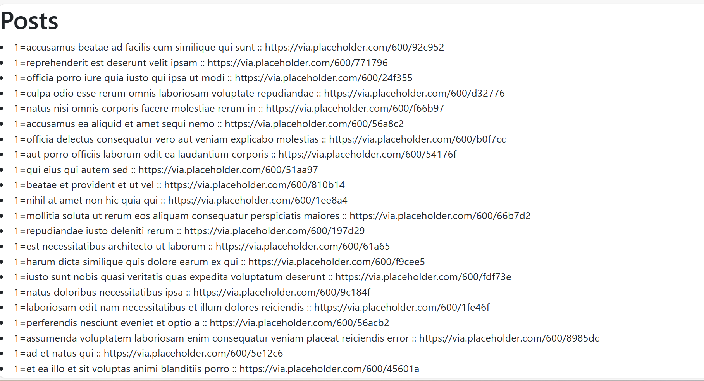

* **Inline Style**

import React,{ useEffect,useState } from 'react;

const App = () => {

   const[data,setData]=useState([])

  useEffect(()=>{fetch('https://jsonplaceholder.typicode.com/posts').then(

    res=>res.json()

  ).then(

    json=>setData(json)

  )}

  )

  return (

    <div>

      <h1 style={{color:'purple'}}>Posts</h1>

      {

        data.map(post=><li style={{color:'red'}} key ={post.id}>{post.title} = {post.id} </li>)

      }

      </div>

  )

}

export default App

**OUPUT:-**

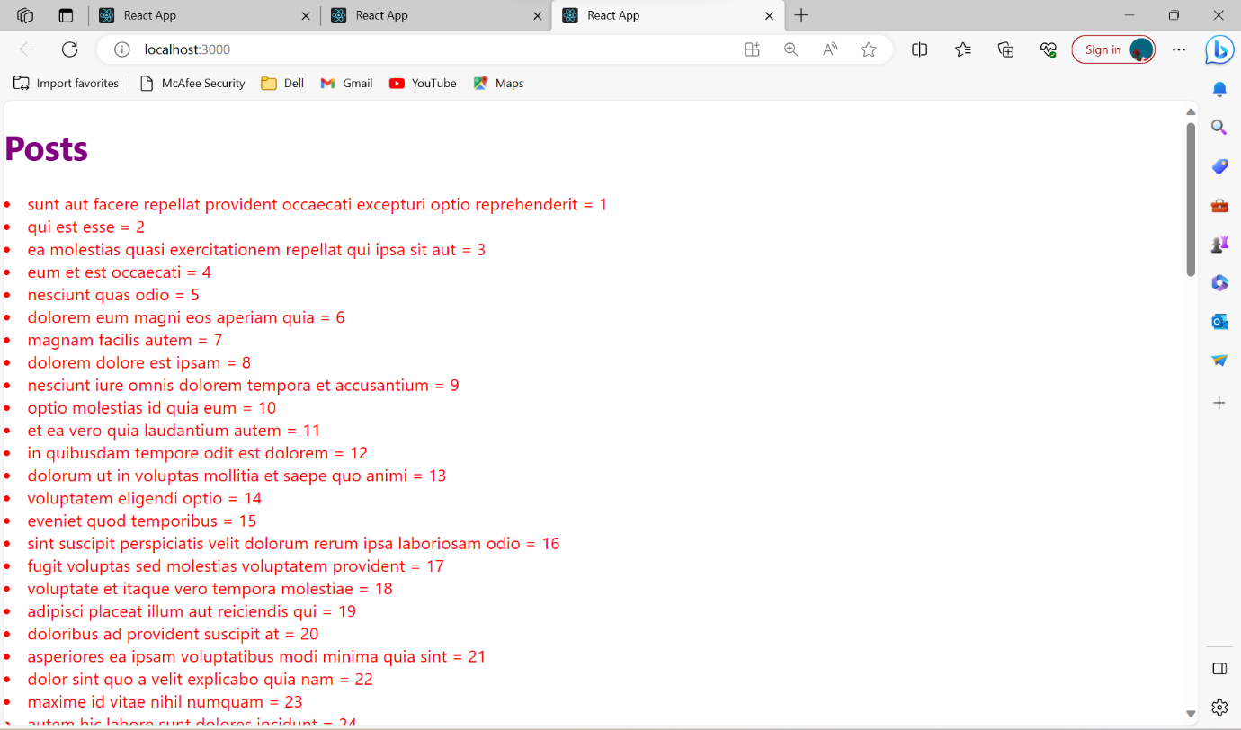

**Internal**

import React,{ useEffect,useState } from 'react'

const App = () => {

   const[data,setData]=useState([])

  useEffect(()=>{fetch('https://jsonplaceholder.typicode.com/albums').then(

    res=>res.json()

  ).then(

    json=>setData(json)

  )}

  )

  const title={

    color:"blue",

    backgroundColor:"orange",

  }

  return (

    <div>

      <h1 style={{color:'green',backgroundColor:'pink',fontFamily:'Times-BoldItalic'}}>Albums</h1>

      <h1 style={{color:'green',backgroundColor:'pink',fontFamily:'Times-Bold'}}>It contains the Details of UserId , Id , Title</h1>

      {

        data.map(post=><li style={title} key ={post.id}>{post.userId} = {post.title} </li>)

      }

      </div>

  )

}

export default App

**OUTPUT:-**

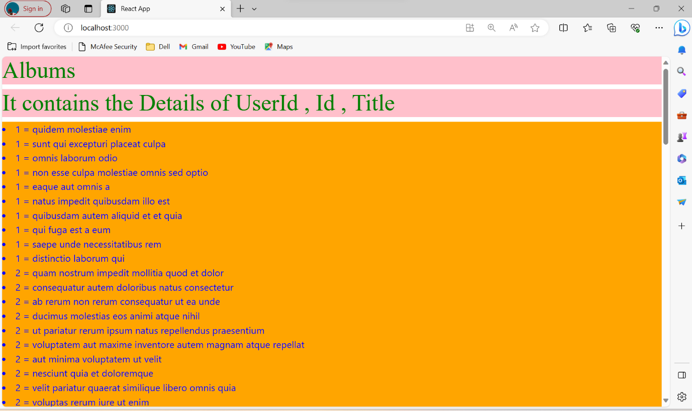

**LOGIN FORM:- with validation**

**App.js**

import React ,{useState,useEffect} from 'react'

const App = () => {

  const[data,setData]= useState({

    username:"",

    password:"",

    confirmpassword:"",

  })

  const changeHandler=(e)=>{

    setData({...data,[e.target.name]:e.target.value})

  }

  const submitHandler=(e)=>{

    e.preventDefault()

    console.log(data)

    if(data.username.length<=6){

      alert("Enter the above char");

    }

    else{

      console.log(data)

  }

}

  return(

    <div class="App">

      <center>

      <form onSubmit={submitHandler}>

        <h2 class="apple"> <u> LOGIN FORM</u></h2><br/>

        <input type="text" name='username' style={{color:"purple"}}  onChange={changeHandler} placeholder='Enter your username'/> <br/> <br/>

        <input type="password" name='password' style={{color:"purple"}} onChange={changeHandler} placeholder='Enter your password'/> <br/> <br/>

      <button name= 'Submit' style={{color:"black"}}>Submit</button>

      </form>

      </center>

    </div>

  )

}

export default App

**Output:-**

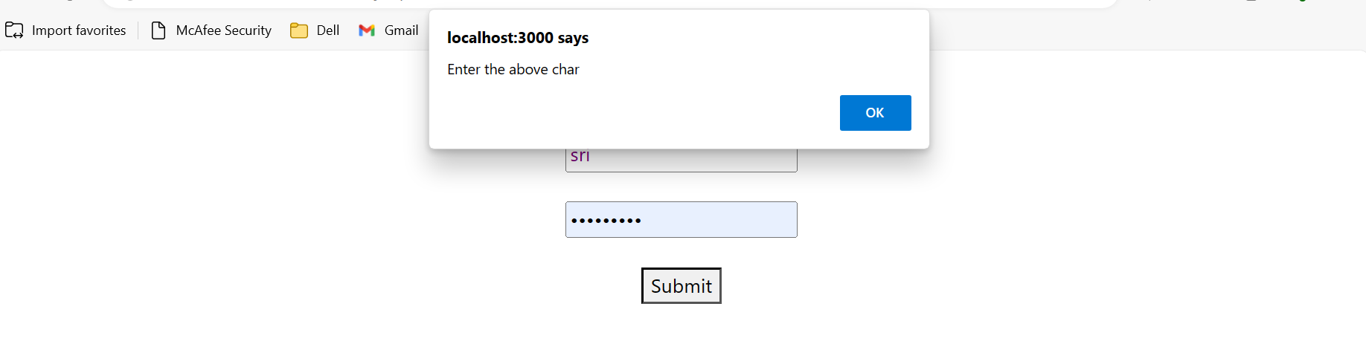

**Without validation:-**

**App.js**

import React ,{useState} from 'react'

const App = () => {

  const[data,setData]= useState({

    username:"",

    password:""

});

  const handler=(e)=>{

    setData({...data,[e.target.name]:e.target.value})

  }

  const submitHandler=()=>{

    console.log(data)

  }

  return(

    <div>

      <center>

        <img src="https://media.istockphoto.com/id/1281150061/vector/register-account-submit-access-login-password-username-internet-online-website-concept.jpg?s=612x612&w=0&k=20&c=9HWSuA9IaU4o-CK6fALBS5eaO1ubnsM08EOYwgbwGBo=" width="300" height="300"></img>

        <h2> <b>LOGIN FORM</b></h2>

      <form onSubmit={submitHandler}>

        <input type="text" name='username' onChange={handler} placeholder='Enter your username'/> <br/><br/>

        <input type="password" name='password' onChange={handler} placeholder='Enter your password'/> <br/><br/>

        <button name= 'Submit'>Submit</button>

      </form>

      </center>

    </div>

  )

}

export default App

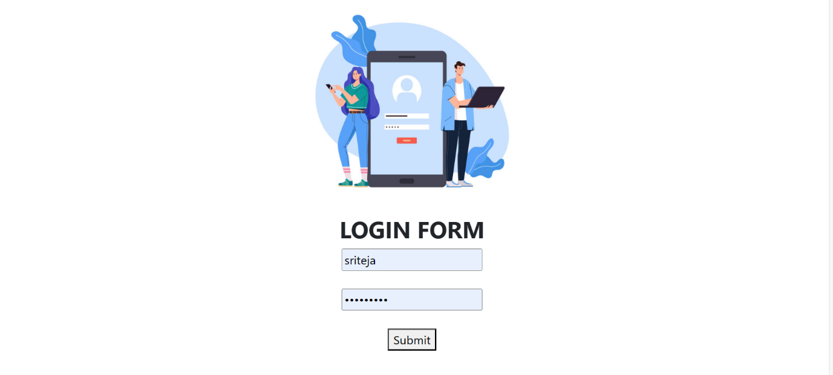

**Registration without validation:-**

import React ,{useState} from 'react'

const App = () => {

  const[data,setData]= useState({

    username:"",

    password:"",

    confirmpassword:"",

    mail:"",

    phoneno:""

  })

  const changeHandler=(e)=>{

    setData({...data,[e.target.name]:e.target.value})

  }

  return(

    <div >

      <center>

      <form>

       <br/>

        <h2 >REGISTRATION FORM</h2>

        <img  src="https://encrypted-tbn0.gstatic.com/images?q=tbn:ANd9GcRp7k7jdUKdnN2P1l-ocZ-MZjs2YLSv6CqQWIqulx8cYUz0-X4HWM2guTjpKmSNN6aoQlk&usqp=CAU"height="150" width="150" ></img> <br/>

        <input type="text" name='username'   onChange={changeHandler} placeholder='Enter your username'/> <br/> <br/>

        <input type="password" name='password'  onChange={changeHandler} placeholder='Enter your password'/> <br/> <br/>

        <input type="password" name='confirmpassword'  onChange={changeHandler} placeholder='Enter your confirm password'/> <br/> <br/>

        <input type="email" name='email'  onChange={changeHandler} placeholder='Enter your Email'/> <br/> <br/>

        <input type="phoneno" name="phoneno"  onChange={changeHandler} placeholder='Enter your phoneno'/> <br/> <br/>

      <button name= 'Submit' >Submit</button>

      </form>

      </center>

    </div>

  )

}

export default App

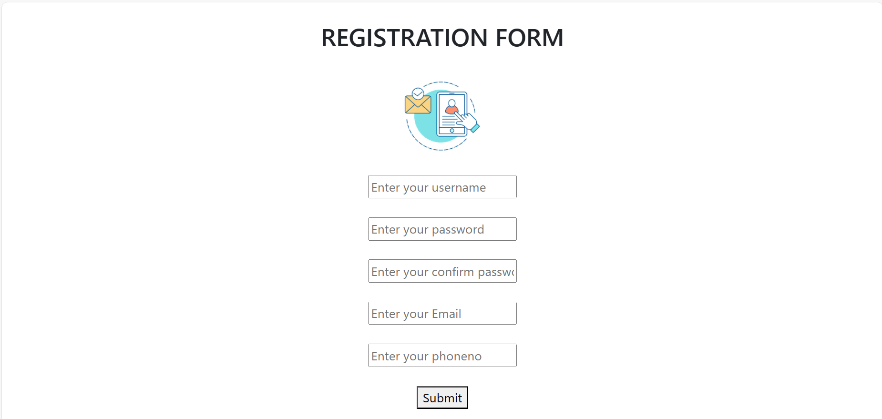

EXP17:- How to get API data using Fetch API and Axios?

USING AXIOS

import axios from 'axios';

import React,{useEffect,useState} from 'react';

function App (){

  const[data,setData]=useState([])

  useEffect(()=>{

    axios.get("https://jsonplaceholder.typicode.com/posts").then(

      res=>setData(res.data)

    )

  })

  return(

    <div>

      {

        data.map(list=><li key={list.id}>{list.title}</li>)

      }

    </div>

  )

}

export default App

EXP 17:- Create Multipage application with using React router ?

App.js

import React, { useEffect } from 'react'

import Navbar from './navigation'

import { BrowserRouter,Routes,Route } from 'react-router-dom'

import Home from './home'

import Dashboard from './dashboard';

import Services from './services';

import Contact from './contact'

const App = () => {

  return (

    <div>

      <BrowserRouter>

      <Navbar/>

      <Routes>

        <Route path='/' element={<Home/>}/>

        <Route path='/dashboard' element={<Dashboard/>}/>

        <Route path='/services' element={<Services/>}/>

        <Route path='/contact' element={<Contact/>}/>

      </Routes>

      </BrowserRouter>

    </div>

  )

}

export default App

Home.js

import React, { useEffect } from 'react'

const Home = () => {

  useEffect =(()=>{

    fetch('https://jsonplaceholder.typicode.com/todos')

      .then(response => response.json())

      .then(json => console.log(json))

      },[])

  return (

    <div>

      <h1>Welcome to React Router Concept</h1>

    </div>

  )

}

export default Home

contact.js

import React from 'react'

const Contact = () => {

  return (

    <div>

      <h1>Welcome to Contact Page</h1>

    </div>

  )

}

export default Contact

services.js

import React, { useEffect, useState } from 'react'

const Services = () => {

  const [data,setData]=useState([]);

useEffect =(()=>{

fetch("https://jsonplaceholder.typicode.com/posts").then(

  response =>response.json()).then(

    json=>console.log(json)

  )

  },[])

  return (

    <div>

      <h1>Welcome to Services page</h1>

      {data.map(item=><li key={item.id}>{item.title}</li>)}

    </div>

  )

}

export default Services

dashboard.js

import React from 'react'

const Dashboard = () => {

  return (

    <div>

      <h1>Welcome to Dashboard</h1>

    </div>

  )

}

export default Dashboard

navigation.js

import React from 'react'

import { Link } from 'react-router-dom'

const Navbar = () => {

  return (

    <div>

        <nav>

            <ul>

                <li><Link to="/" >Home</Link></li>

                <li><Link to="/dashboard">Dashboard</Link></li>

                <li><Link to="/services">Services</Link></li>

                <li><Link to="/contact">Contact</Link></li>

            </ul>

        </nav>

    </div>

  )

}

export default Navbar

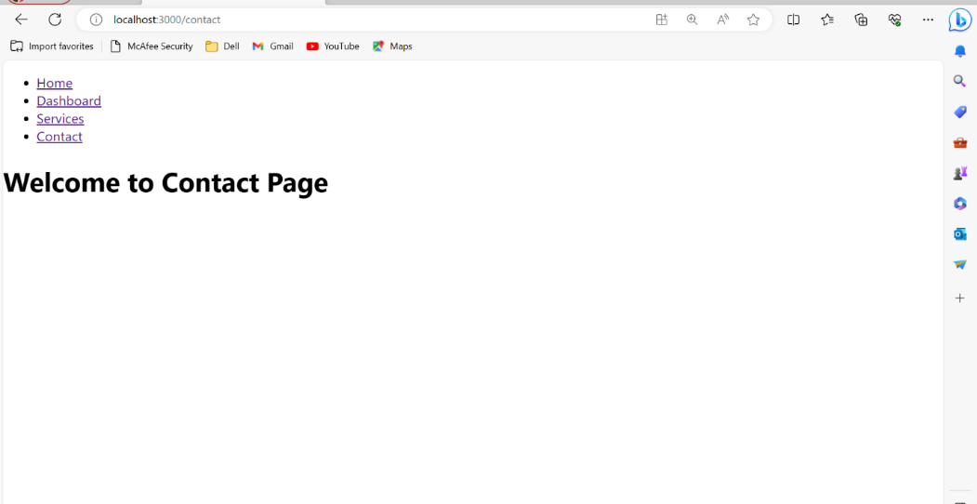output:-